CSY3024

Databases 3
Portfolio
Joshua Luke Perry (21427656)
Table of Contents
1 Introduction 5
2 Relational Databases Review 5
2.1 Activities 5
2.2 Reflection 5
3 Introduction to NoSQL 5
3.1 Activities 5
3.2 Reflection 5
4 Cypher 5
4.1 Week 1 5
4.1.1 Activities 5
4.1.2 Reflection 5
4.2 Week 2 5
4.2.1 Activities 5
4.2.2 Reflection 5
4.3 Week 3 5
4.3.1 Activities 6
4.3.2 Reflection 6
4.4 Week 4 6
4.4.1 Activities 6
4.4.2 Reflection 6

Index of Tables

Table of Figures

1 Introduction

2 Relational Databases Review

2.1 Library Management System Schema
This was a series of questions producing SQL queries for a Database that manages the books, borrowers, and loans made at different library branches managed by the company.
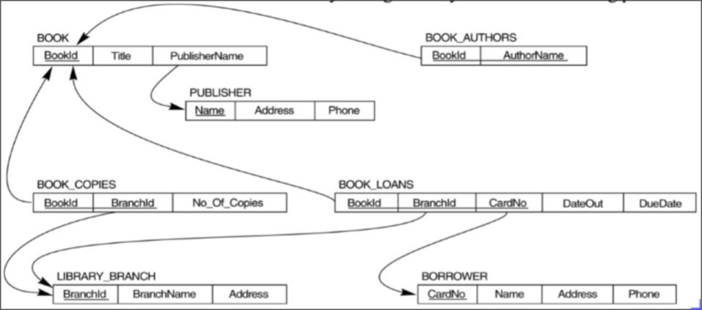Figure 1: The ERD for the Library Management System

2.1.1 How many copies of the book titled “The Lost Tribe” are owned by the library branch whose name is “Sharpstown”
1 SELECT No_Of_Copies FROM BOOK_COPIES
2 WHERE BookId = (SELECT BookId FROM BOOK WHERE Title = “The Lost Tribe”)
3 AND BranchId = (SELECT BranchId FROM LIBRARY_BRANCH WHERE BranchName = “Sharpstown”);

2.1.2 How many copies of the book titled “The Lost Tribe” are owned by each library branch
1 SELECT lb.BranchName AS branch_name,
2 bc.NO_Of_Copies AS number_of_copies
3 FROM BOOK_COPIES bc
4 JOIN LIBRARY_BRANCH lb ON bc.BranchId = lb.BranchId
5 JOIN BOOK b ON bc.BookId = b.BookId
6 WHERE b.title = “The Lost Tribe”;

2.1.3 Retrieve the names of all borrowers who do not have any books checked out
1 SELECT Name FROM BORROWER
2 WHERE CardNo NOT IN (
3 SELECT CardNo FROM BOOK_LOANS
4 );

2.1.4 For each book that is loaned out from the “Sharpstown” branch and whose DueDate is today, retrieve the book title, the borrower’s name, and the borrower’s address
1 SELECT b.Title, bo.Name, bo.Address
2 FROM BOOK_LOANS bl
3 JOIN BOOK b ON bl.BookId = b.BookId
4 JOIN BORROWER bo ON bl.CardNo = bo.CardNo
5 WHERE bl.DueDate = NOW()
6 AND bl.BranchId = (
7 SELECT BranchId FROM LIBRARY_BRANCH
8 WHERE BranchName = “Sharpstown”
9 );

2.1.5 For each library branch, retrieve the branch name and the total number of books loaned out from that branch
1 SELECT lb.BranchName, COUNT(bl.*) AS total_loans
2 FROM BOOK_LOANS bl
3 JOIN LIBRARY_BRANCH lb ON bl.BranchID = lb.BranchId
4 GROUP BY bl.BranchID;

2.1.6 Retrieve the names, addresses, and number of books checked out for all borrowers who have more than five books checked out
1 SELECT b.Name, b.Address, COUNT(bl.*) AS total_loans
2 FROM BOOK_LOANS bl
3 JOIN BORROWER b ON bl.CardNo = b.CardNo
4 GROUP BY bl.CardNo
5 HAVING COUNT(bl.*) > 5;

2.1.7 For each book authored (or co-authored) by “Stephen King”, retrieve the title and the number of copies owned by the library branch whose name is “Central”
1 SELECT b.Title, bc.No_Of_Copies
2 FROM BOOK b
3 JOIN BOOK_COPIES bc ON b.BookId = bc.BookId
4 WHERE b.BookID = (
5 SELECT BookId FROM BOOK_AUTHORS
6 WHERE AuthorName = “Stephen King”
7 )
8 AND bc.BranchID = (
9 SELECT BranchId FROM LIBRARY_BRANCH
10 WHERE BranchName = “Central”
11 );

2.2 Company Schema
This was a series of questions producing SQL queries for a Database that manages the inner-workings of a company including employees, departments, and projects.
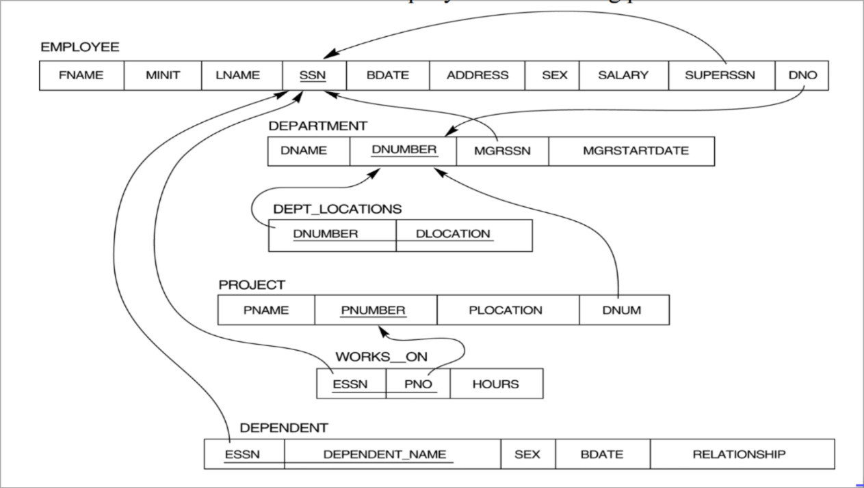Figure 2: The ERD for the Company

2.2.1 Retrieve the names of employees in department 5 who work more than 10 hours per week on the “ProductX” project
1 SELECT FNAME AS first_name, LNAME AS last_name
2 FROM EMPLOYEE
3 WHERE DNO = 5
4 AND SSN = (
5 SELECT ESSN FROM WORKS_ON
6 WHERE HOURS > 10
7 AND PNO = (
8 SELECT PNUMBER FROM PROJECT
9 WHERE PNAME = “ProductX”
10 )
11 );

2.2.2 For each project, list the project name and the total hours per week (by all employees) spent on that project
1 SELECT p.PNAME AS project_name, SUM(wo.HOURS) AS total_hours
2 FROM PROJECT p
3 JOIN WORKS_ON wo ON p.PNUMBER = wo.PNO;

2.2.3 Retrieve the names of the employees who work on every project
1 SELECT e.FNAME AS first_name, e.LNAME AS last_name
2 FROM WORKS_ON wo
3 JOIN EMPLOYEE e ON wo.ESSN = e.SSN
4 JOIN PROJECT p ON wo.PNO = p.PNUMBER
5 GROUP BY e.SSN
6 HAVING COUNT(DISTINCT p.PNUMBER) = (
7 SELECT COUNT(DISTINCT PNUMBER) FROM PROJECT
8 );

2.2.4 Retrieve the names of employees who do not work on any project
1 SELECT FNAME AS first_name, LNAME AS last_name
2 FROM EMPLOYEE
3 WHERE SSN NOT IN (
4 SELECT ESSN FROM WORKS_ON
5 );

2.2.5 Find the names and addresses of employees who work on at least one project located in “Houston” but whose department has no location in “Houston”
1 SELECT e.FNAME AS first_name, e.LNAME AS last_name
2 FROM EMPLOYEE e
3 JOIN WORKS_ON wo ON e.SSN = wo.ESSN
4 WHERE wo.PNO = (
5 SELECT PNUMBER FROM PROJECT
6 WHERE PLOCATION = “Houston”
7 )
8 AND e.DNO NOT IN (
9 SELECT DNUMBER FROM DEPT_LOCATIONS
10 WHERE DLOCATION = “Houston”
11 );

2.2.6 List the last names of department managers who have no dependents
1 SELECT FNAME AS first_name, LNAME AS last_name
2 FROM EMPLOYEE
3 WHERE SSN = (
4 SELECT MGRSSN FROM DEPARTMENT
5 )
6 AND SSN NOT IN (
7 SELECT ESSN FROM DEPENDENT
8 );

2.2.7 Find details of those employees whos salary is greater than the average salary for all employees. Output salary in descending order.
1 SELECT * FROM EMPLOYEE
2 WHERE SALARY > (
3 SELECT AVG(SALARY) FROM EMPLOYEE
4 )
5 ORDER BY SALARY DESC;

2.2.8 Find details of those employees whose salary is greater than the average salary for all the employees in his/her department. Output salary in ascending order
1 WITH department_avg AS (
2 SELECT DNO, AVG(SALARY) AS avg
3 FROM EMPLOYEE
4 GROUP BY DNO
5 )
6 SELECT * FROM EMPLOYEE e
7 JOIN department_avg da ON e.DNO = da.DNO
8 WHERE e.SALARY > da.avg
9 ORDER BY e.SALARY ASC;

2.3 ERD Exercise
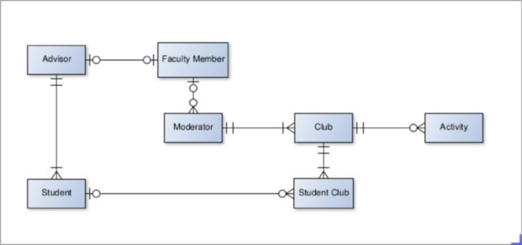Figure 3: The ERD produced for the Club Scenario

