CSY3025

Artificial Intelligence Techniques
Assignment 1
Joshua Luke Perry (21427656)
Table of Contents
1 Introduction 8
2 Data Exploration and Preproccessing 8
2.1 Missing Values 8
2.2 Target Variable 8
2.3 Columns 9
2.3.1 Longitude 9
2.3.1.1 Semantic Definition 9
2.3.1.2 Summary Statistics 9
2.3.2 Latitude 9
2.3.2.1 Semantic Definition 9
2.3.2.2 Summary Statistics 10
2.3.3 Housing Median Age 10
2.3.3.1 Semantic Definition 10
2.3.3.2 Summary Statistics 10
2.3.4 Total Rooms 10
2.3.4.1 Semantic Definition 10
2.3.4.2 Summary Statistics 11
2.3.5 Total bedrooms 11
2.3.5.1 Semantic Definition 11
2.3.5.2 Missing Values 11
2.3.5.2.1 Nature of Missing Values 11
2.3.5.2.1.1 Visualisations 12
2.3.5.2.1.2 Analysis 13
2.3.5.2.2 Selected Technique to Handle Missing Values 13
2.3.5.2.3 Results 14
2.3.5.3 Summary Statistics 15
2.3.5.3.1 Before Imputation 15
2.3.5.3.2 After Imputation 15
2.3.6 Population 15
2.3.6.1 Semantic Definition 15
2.3.6.2 Summary Statistics 16
2.3.7 Households 16
2.3.7.1 Semantic Definition 16
2.3.7.2 Summary Statistics 16
2.3.8 Median Income 16
2.3.8.1 Semantic Definition 17
2.3.8.2 Summary Statistics 17
2.3.9 Median House Value 17
2.3.9.1 Semantic Definition 17
2.3.9.2 Summary Statistics 17
2.3.10 Ocean Proximity 18
2.3.10.1 Semantic Definition 18
2.3.10.2 Categorical Summary 18
2.4 Outliers 18
2.4.1 Visualisations 18
2.4.2 Selected Technique to Handle Outliers 20
3 Feature Engineering 21
4 Normalisation 21
4 Model Selection 21
5 Model Implementation 21
6 Evaluation 22
7 Conclusion 22
References 23
Appendix 1 – Glossary 24
Appendix 2 – Generated Visualisations 25
2.1 Missing Value Nature Analysis 25
2.2 KNN Imputation Results 26
2.3 Outlier Analysis 26
2.4 Outlier Removal Results 26
Appendix 3 - Development Environment 27
3.1 Pacman Packages 27
3.2 Virtual Environment 27
3.2.1 Setup 27
3.2.2 Requirements.txt 27
3.2.3 Usage 27

Index of Tables
Table 1: Summary statistics for the longitude column 9
Table 2: Summary statistics for the latitude column 10
Table 3: Summary statistics for the housing_median_age column 10
Table 4: Summary statistics for the total_rooms column 11
Table 5: Summary statistics for the total_bedrooms column before handling missing values 15
Table 6: Summary statistics for the total_bedrooms column after handling missing values 15
Table 7: Summary statistics for the population column 16
Table 8: Summary statistics for the households column 16
Table 9: Summary statistics for the median_income column 17
Table 10: Summary statistics for the median_house_value column 17
Table 11: The Frequency each catageory appears in the dataset 18

Table of Figures
Figure 1: Visualisation of missing values in relation to population and total bedrooms 12
Figure 2: Visualisation of missing values in relation to total rooms and total bedrooms 12
Figure 3: Visualisation of missing values in relation to households and total bedrooms 12
Figure 4: Visualisation of missing values in relation to median income and total bedrooms 12
Figure 5: Visualisation of imputed values of population against total bedrooms 14
Figure 6: Visualisation of imputed values of total rooms against total bedrooms 14
Figure 7: Visualisation of imputed values of households against total bedrooms 14
Figure 8: Visualisation of imputed values of median income against total bedrooms 14
Figure 9: A box plot of median income 18
Figure 10: A box plot of population 18
Figure 11: A boxplot of households 19
Figure 12: A box plot of median income after outliers have been handled 20
Figure 13: A box plot of population after outliers have been handled 20
Figure 14: A box plot of households after outliers have been handled 20
Figure 15: Visualisation of missing values in relation to longitude and total bedrooms 25
Figure 16: Visualisation of missing values in relation to latitude and total bedrooms 25
Figure 17: Visualisation of missing values in relation to median house value and total bedrooms 25
Figure 18: Visualisation of missing values in relation to housing median age and total bedrooms 25
Figure 19: Visualisation of missing values in relation to ocean proximity and total bedrooms 26

1 Introduction
The aim of this project is to produce a random forest regression model that exceeds the accuaracy of the baseline linear regression model. The model has been designed to estimate median housing prices for districts in California.

2 Data Exploration and Preproccessing
The exploration done on this dataset was done using the exploration program written for this project (See Appendix 2).

2.1 Missing Values
Missing values can cause many issues. The most serious of these issues are:
- Emmergent bias in the model due to differences between the gathered dataset and the complete dataset.
- Irregularities in the data caused by missing values can lead to difficulties modelling the dataset accurately.
- Efficiency and informational accuracy can be reduced by an incomplete dataset
(Barnard and Meng, 1999)
To handle these issues in the dataset in use, each column was delt with on a case by case basis. Although, this dataset only presented one column with incomplete data. This column was the “total_bedrooms” column (See Section 2.2.4).

2.2 Target Variable
The column “median_house_value” was selected to be the target variable. This is because the aim of the project is to produce a model that can predict the median value of a house.

2.3 Columns
All definitions below are as found on the data card for this dataset on Kaggle. (https://www.kaggle.com/datasets/camnugent/california-housing-prices)
However, all summary statstics have been gleaned from my own data exploration. All but one column has the double-prescision floating-point datatype. The one column without this type (“ocean_proximity”) has the object data type instead (See Section 2.2.9).

2.3.1 Longitude
This column’s header is: “longitude”.

2.3.1.1 Semantic Definition
A measure of how far west a house is; a higher value is farther west.

2.3.1.2 Summary Statistics
Statistic | Longitude (°)
Mean (μ_{longitude}) | -199.569704
Standard deviation (σ_{longitude}) | 2.003532
Minimum (min_{longitude}) | -124.35
Maximum (max_{longitude}) | -114.31
25th Percentile (Q¹_{longitude}) | -121.8
50th Percentile (Q²_{longitude}) | -118.49
75th Percentile (Q³_{longitude}) | -118.01
Table 1: Summary statistics for the longitude column

2.3.2 Latitude
This column’s header is: “latitude”.

2.3.2.1 Semantic Definition
A measure of how far north a house is; a higher value is farther north.

2.3.2.2 Summary Statistics
Statistic | Latitude (°)
Mean (μ_{latitude}) | 35.631861
Standard deviation (σ_{latitude}) | 2.135952
Minimum (min_{latitude}) | 32.54
Maximum (max_{latitude}) | 41.95
25th Percentile (Q¹_{latitude}) | 33.93
50th Percentile (Q²_{latitude}) | 34.26
75th Percentile (Q³_{latitude}) | 37.71
Table 2: Summary statistics for the latitude column

2.3.3 Housing Median Age
This column’s header is: “housing_median_age”.

2.3.3.1 Semantic Definition
Median age of a house within a block; a lower number is a newer building.

2.3.3.2 Summary Statistics
Statistic | Age (years)
Mean (μ_{housing_median_age}) | 28.639486
Standard deviation (σ_{housing_median_age}) | 12.585558
Minimum (min_{housing_median_age}) | 1.0
Maximum (max_{housing_median_age}) | 52.0
25th Percentile (Q¹_{housing_median_age}) | 18.0
50th Percentile (Q²_{housing_median_age}) | 29.0
75th Percentile (Q³_{housing_median_age}) | 37
Table 3: Summary statistics for the housing_median_age column

2.3.4 Total Rooms
This column’s header is: “total_rooms”.

2.3.4.1 Semantic Definition
Total number of rooms within a block.

2.3.4.2 Summary Statistics
Statistic | Rooms
Mean (μ_{total_rooms}) | 2635.763081
Standard deviation (σ_{total_rooms}) | 2181.615252
Minimum (min_{total_rooms}) | 2.0
Maximum (max_{total_rooms}) | 39320.0
25th Percentile (Q¹_{total_rooms}) | 1447.75
50th Percentile (Q²_{total_rooms}) | 2127.0
75th Percentile (Q³_{total_rooms}) | 3178
Table 4: Summary statistics for the total_rooms column

2.3.5 Total bedrooms
This column’s header is: “total_bedrooms”.

2.3.5.1 Semantic Definition
Total number of bedrooms within a block

2.3.5.2 Missing Values

2.3.5.2.1 Nature of Missing Values
This column has 207 missing values. To determine the nature of the missing values, the dataset was first inspected using a corrolation matrix heatmap (See Figure 5 below) to examine which columns had the strongest relationship with the total_bedrooms column. This was determined to be the population, total_rooms, households, and median_income columns.
These relationships were then visualised using scatter plots to determine if the missing values had a corrolation to these columns too. To do this, the rows of data with missing values were plotted as red lines bisecting the x axis at the value of the other column related to that row.
Only the visualisations that were felt to be relevent to the analysis have been included below.

2.3.5.2.1.1 Visualisations
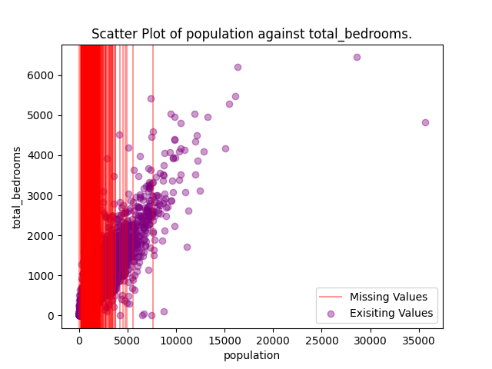Figure 1: Visualisation of missing values in relation to population and total bedrooms
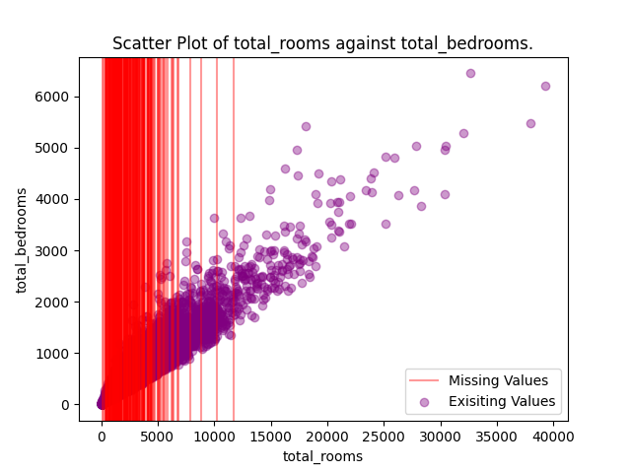Figure 2: Visualisation of missing values in relation to total rooms and total bedrooms

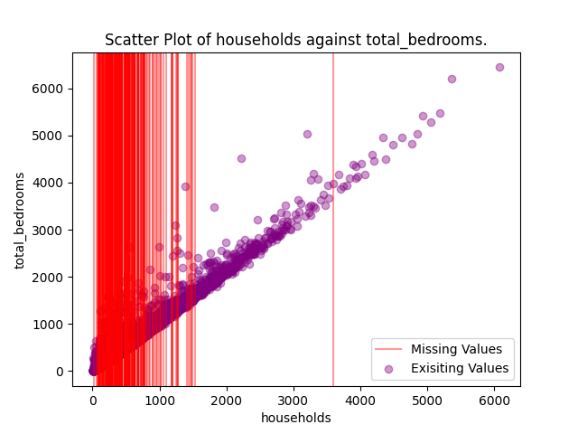Figure 3: Visualisation of missing values in relation to households and total bedrooms
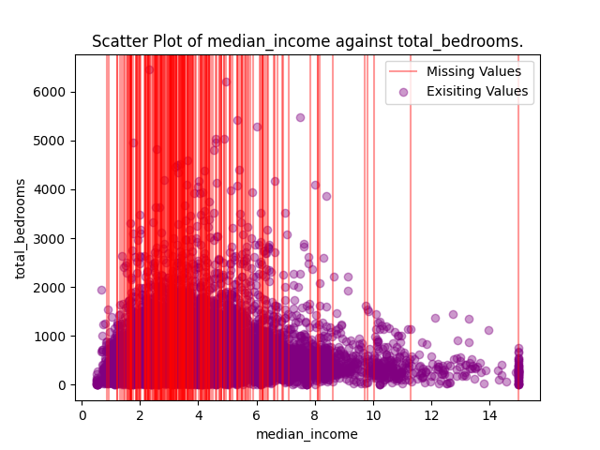Figure 4: Visualisation of missing values in relation to median income and total bedrooms

2.3.5.2.1.2 Analysis
As seen in the figures above, the missing values seem to group towars the origin of the x axis on each graph. Figures 1-3 suggest that surveyors of lower density areas had could not provide complete data. This could be due to geoprahpic difficulties or other external issues. Furthermore, figure 4 suggests that areas of lower income were less likely to complete the survey. This is again most likely to external issues.
The distribution of missing values seem to sugges that they are missing at random (MAR). This is because the missing values seem to have a relationship with the observed columns in Figures 1-4. (Kwak and Kim, 2017)

2.3.5.2.2 Selected Technique to Handle Missing Values
The technique selected to deal with the missing values is K Nearest Neighbour imputation. This method was selected because it allows the use of imputed values to calculate other imputed values (Gajawada and Toshniwal, 2012). This will allow the model to scale if trained on a dataset with a larger percentage of missing values. However, results should still be compared with the distribution of the original data to make sure errors have not occurred and propogated through subsequent imputations (Gajawada and Toshniwal, 2012). In KNN, the K is the number of nearest neighbours to consider when imputing the value. The optimal value of K for each dataset is different so the method of trial and error was used to find the value that lead to the best imputed results.
This K value was 9. As seen in the figures below, the imputed data has minimal disparity with the original dataset.

2.3.5.2.3 Results
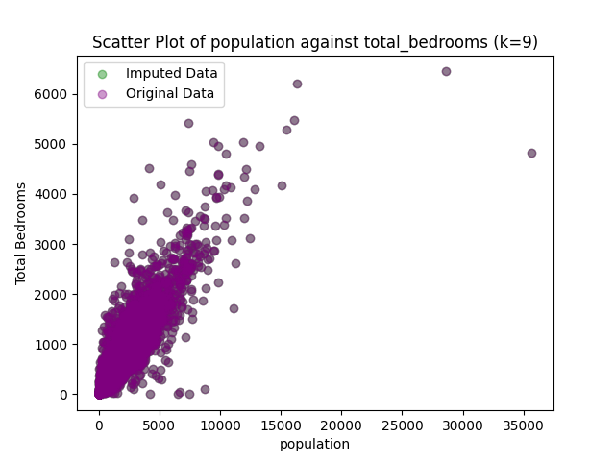Figure 5: Visualisation of imputed values of population against total bedrooms
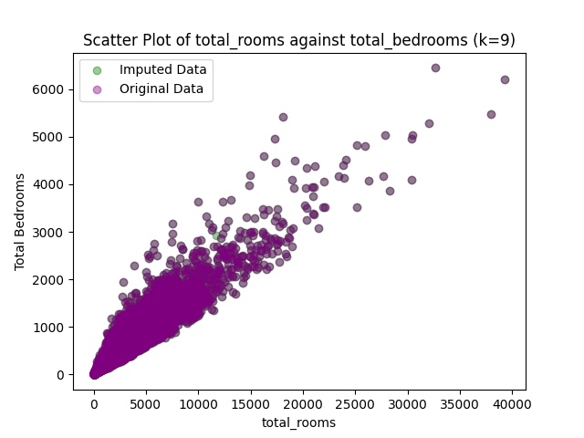Figure 6: Visualisation of imputed values of total rooms against total bedrooms

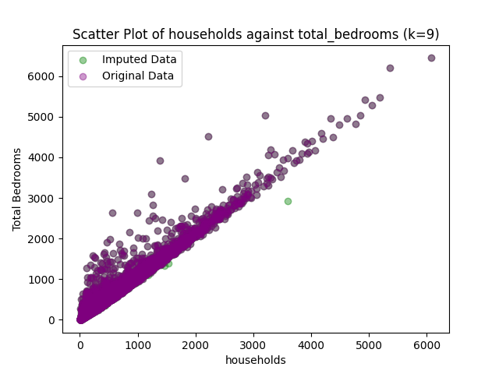Figure 8: Visualisation of imputed values of households against total bedrooms
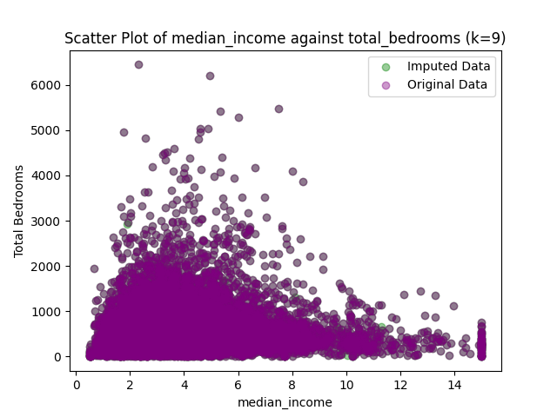Figure 7: Visualisation of imputed values of median income against total bedrooms

2.3.5.3 Summary Statistics

2.3.5.3.1 Before Imputation
Statistic | Bedrooms
Mean (μ_{total_bedrooms}) | 537.870553
Standard deviation (σ_{total_bedrooms}) | 421.385070
Minimum (min_{total_bedrooms}) | 1.0
Maximum (max_{total_bedrooms}) | 6445.0
25th Percentile (Q¹_{total_bedrooms}) | 296.0
50th Percentile (Q²_{total_bedrooms}) | 435.0
75th Percentile (Q³_{total_bedrooms}) | 647
Table 5: Summary statistics for the total_bedrooms column before handling missing values

2.3.5.3.2 After Imputation
Statistic | Bedrooms
Mean (μ_{total_bedrooms}) | 537.833592
Standard deviation (σ_{total_bedrooms}) | 420.935736
Minimum (min_{total_bedrooms}) | 1.0
Maximum (max_{total_bedrooms}) | 6445.0
25th Percentile (Q¹_{total_bedrooms}) | 295.416667
50th Percentile (Q²_{total_bedrooms}) | 435.0
75th Percentile (Q³_{total_bedrooms}) | 647
Table 6: Summary statistics for the total_bedrooms column after handling missing values

2.3.6 Population
This column’s header is: “population”.

2.3.6.1 Semantic Definition
A measure of how far north a house is; a higher value is farther north.

2.3.6.2 Summary Statistics
Statistic | Population
Mean (μ_{population}) | 1425.476744
Standard deviation (σ_{population}) | 1132.462122
Minimum (min_{population}) | 3.0
Maximum (max_{population}) | 35682.0
25th Percentile (Q¹_{population}) | 787.0
50th Percentile (Q²_{population}) | 1166.0
75th Percentile (Q³_{population}) | 1725
Table 7: Summary statistics for the population column

2.3.7 Households
This column’s header is: “households”.

2.3.7.1 Semantic Definition
Total number of households, a group of people residing within a home unit, for a block.

2.3.7.2 Summary Statistics
Statistic | Households
Mean (μ_{households}) | 499.53968
Standard deviation (σ_{households}) | 382.329753
Minimum (min_{households}) | 1.0
Maximum (max_{households}) | 6082.0
25th Percentile (Q¹_{households}) | 280.0
50th Percentile (Q²_{households}) | 409.0
75th Percentile (Q³_{households}) | 605
Table 8: Summary statistics for the households column

2.3.8 Median Income
This column’s header is: “median_income”.

2.3.8.1 Semantic Definition
Median income for households within a block of houses (measured in tens of thousands of US Dollars).

2.3.8.2 Summary Statistics
Statistic | Income ($10,000×)
Mean (μ_{median_income}) | 3.870671
Standard deviation (σ_{median_income}) | 1.899822
Minimum (min_{median_income}) | 0.4999
Maximum (max_{median_income}) | 15.0001
25th Percentile (Q¹_{median_income}) | 2.5634
50th Percentile (Q²_{median_income}) | 3.5348
75th Percentile (Q³_{median_income}) | 4.74
Table 9: Summary statistics for the median_income column

2.3.9 Median House Value
This column’s header is: “median_house_value”.

2.3.9.1 Semantic Definition
Median house value for households within a block (measured in US Dollars).

2.3.9.2 Summary Statistics
Statistic | Value ($1×)
Mean (μ_{median_house_value}) | 206855.816909
Standard deviation (σ_{median_house_value}) | 115395.615874
Minimum (min_{median_house_value}) | 14999.0
Maximum (max_{median_house_value}) | 500001.0
25th Percentile (Q¹_{median_house_value}) | 119600.0
50th Percentile (Q²_{median_house_value}) | 179700.0
75th Percentile (Q³_{median_house_value}) | 264725
Table 10: Summary statistics for the median_house_value column

2.3.10 Ocean Proximity
This column’s header is: “ocean_proximity”.
The values of this columns have been mapped to the numerical values 1 to 5.

2.3.10.1 Semantic Definition
Location of the house with relation to the ocean/sea.

2.3.10.2 Categorical Summary
Category | Frequency
OCEAN | 9136
INLAND | 6551
ISLAND | 5
NEAR BAY | 2290
NEAR OCEAN | 2658
Table 11: The Frequency each catageory appears in the dataset

2.4 Outliers
The reason we need to consider the outliers in the dataset is because they can affect the statistical averages of our dataset. These outliers can be identified visually by viewing any data that falls outside the whiskers of a boxplot (Kwak and Kim, 2017).

2.4.1 Visualisations
These are some of the most notable columns with outliers (See Appendix 2.3 for other columns).
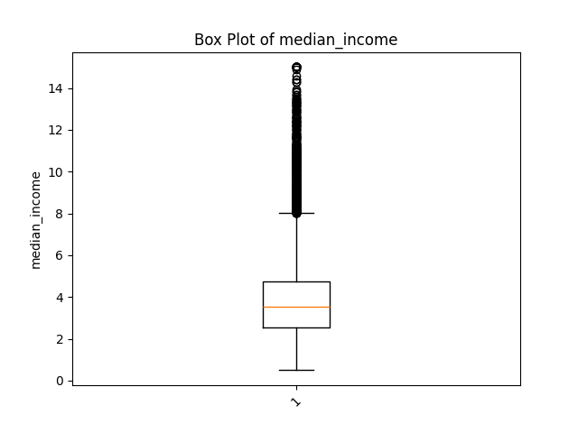Figure 9: A box plot of median income
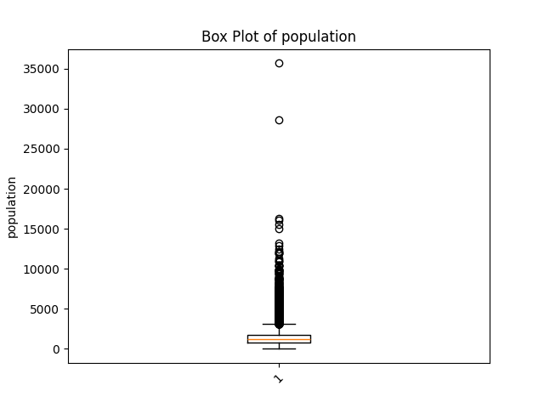Figure 10: A box plot of population

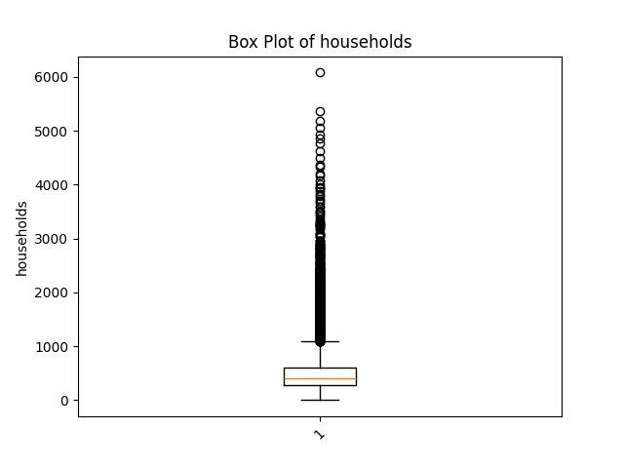Figure 11: A boxplot of households

2.4.2 Selected Technique to Handle Outliers
To handle the outliers the z score technique was selected. The z score of value tells us how many standard deviations from the mean that value lies (Daines, n.d.). With this information, a threshold can be selected. Since a single standard deviation contains 68% of the data (Anon, n.d.), we can fine-tune our threshold with a decimal value to find the value that eliminates the most outliers and increases the accuracy of our models while preserving as much of the data as possible.
After testing some different values, the values 1.3412 was found to be the best threshold value to eliminate outliers and maximise model accuracy. As seen below, this has removed the majority of outliers.
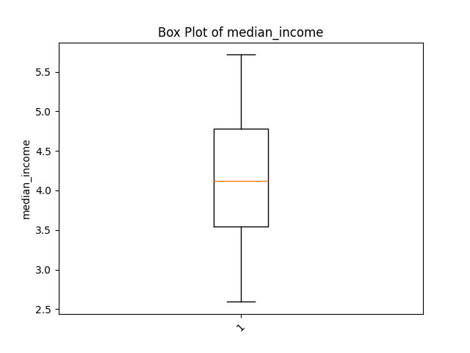Figure 12: A box plot of median income after outliers have been handled
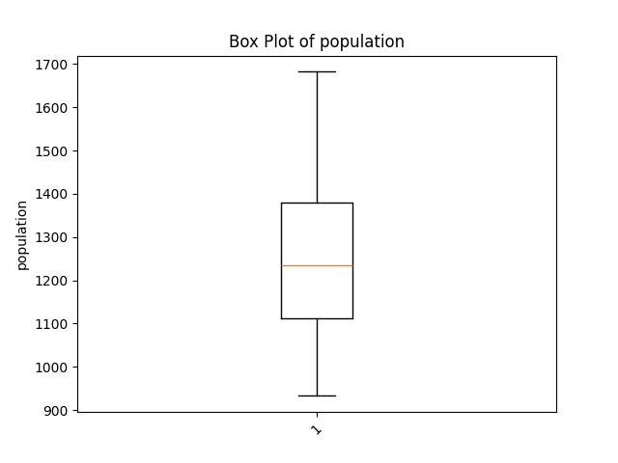Figure 13: A box plot of population after outliers have been handled

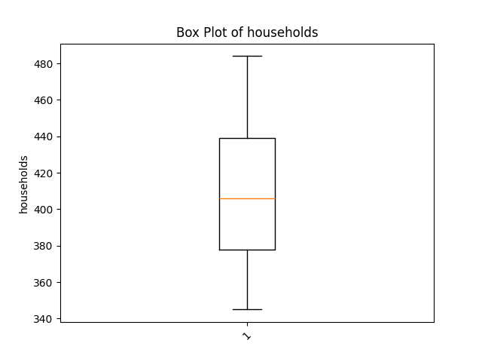Figure 14: A box plot of households after outliers have been handled

3 Feature Engineering
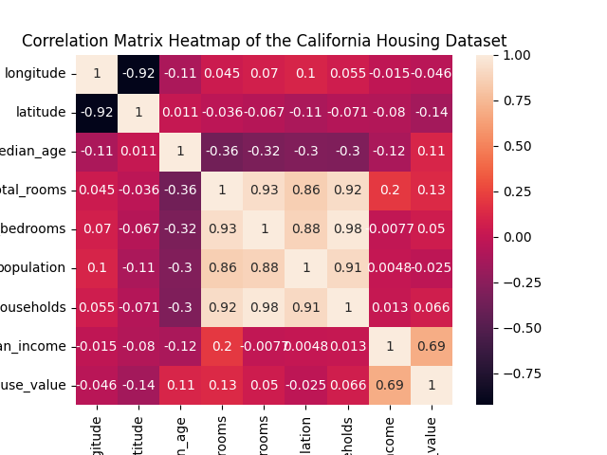Figure 15: A correlation matrix comparing all the columns in the dataset

As seen in the correlation matrix above, the column with the strongest correlation to the target variable is the “median_income” column. Conversly, the “total_rooms”, “total_bedrooms”, and “households” columns have a weak correlation. These features could be transformed to increase their usability within the model. A good starting point is to try and derive common domain-specific features used in other statistical analyses of similar domains.

3.1 Rooms in Household
Data from the HM Land Registry show a positive corrolation between the number of rooms a house has and the valuation it is given (Jennings and Lewis, 2017). This feature is available through the columns “total_rooms” and “households”. Per their semantic definitions, each column represents the rooms and houses in a block of houses respectively. Therefore, the ratio of total_rooms : households will yield the average number of rooms per household in that block of houses.

3.2 Population in Household
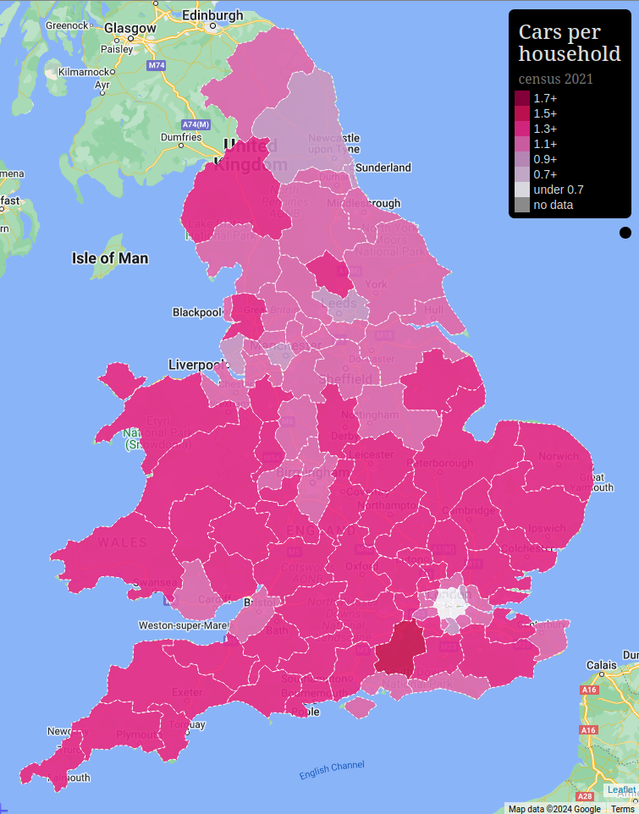Figure 17: A heatmap of the cars per household in the United Kingdom
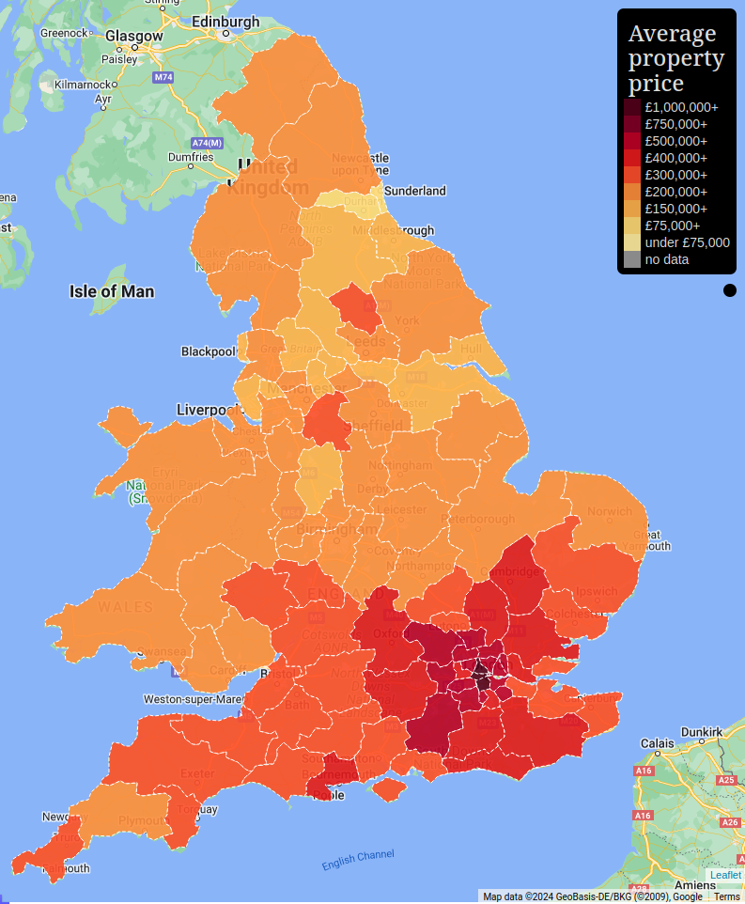Figure 16: A heatmap of the average property price in the United Kingdom

As seen in the heatmaps above, the density of people in an area is related to the number of cars per household (Plumplot, n.d.). Although not a perfect metric, the number of houses per house can be suggestive of the number of people living at a household. The only anomoly with the heatmaps above is that London has the lowest cars per household ratio. This will be because of the public transportation infrastructure in the city.
To calculate the average population in a household from existing features, the population column can be divided by the households column.

3.3 Feature Removal
Due to trial and error, it was discovered that with the removal of the “total_rooms”, “total_bedrooms”, and “housing_median_age” columns, the model became more accurate.
The “total_rooms” column was made redundant by the “rooms_in_household” feature created.

4 Normalisation
Normalisation is necessary for many machine learning models. This is because bias can be introduced by the scale of the values in each feature. Normalisation is the process of transforming every value in a dataset to a value between 0 and 1. This preserves the distirbution of the values. Meaning the relationships, patterns, mean, and standard deviation remain the same.
Before normalisation was done on this dataset, to reduce bias further all monetary columns were re-scaled to match the monetary scale of the target variable.
Min-max scaling is a method of normalisation that uses the maximum and minumum values of a feature to normalise the values. The equation used is:
x_{scaled} = (x – x_{min})/(x_{max} - x_{min)}

4 Model Selection
The algorithm selected to model the data is Random Forest Regression (RFR). RFR is an ensemble model that uses multiple decision trees to generate a prediction that varies less than that of any of the individual trees on their own.
RFR samples the dataset randomly into subsets. These subsets can have repetition as the samples are not removed from the dataset. Each subset is then used to create a seperate decision tree. The candidates chosen for splitting at each node are selected randomly to ensure that the trees do not have a strong correlation with each other.
The trees are grown to their maximum depth. For this project the defaults were used scikit library, which states the tree will grow until all leaves are pure or all leaves cannot be split further (Anon, n.d.). This will result with trees with a low bias but high variance. Predictions are then made by taking the mean of the individual predictions made by each tree.
This algorithim was selected because it is extremely robust. It can handle non-linear relationships, overfitting, outliers, and missing values. This makes the preprocessing steps for a model implemented this way to be a lot more straight forward. It also allows the model to be scaled to a more large and/or complex dataset with ease. (James et al., 2021; Ade-Ojo, 2021; Gao et al., 2022)

5 Model Implementation

5.1 Random Forest Regression
RFRs also have several hyperparameters that can be modified to try and improve the predictive performance of the model. These are: “max_features”, “criterion”, “random_state”, and “n_jobs”. Once the hyperparameters are set, the model needs to be fit to the training dataset’s features and target variable. After, the model is able to predict the target variable given some features.

5.2.1 max_features
The max_features parameter defines the maximum number of features to consider when splitting a leaf (Anon, n.d.). This has been set to log2 for this project after trial and error testing showed it to reduce the Mean Squared Error (MSE) the most.

5.2.2 criterion
The criterion parameter defines the evaluation function to be used to evaluate the quality of each leaf split (Anon, n.d.). This has been set to Mean Absolute Error (MAE) for this project. This was because it minimised the MSE the most out of other evaluation functions.

5.2.3 random_state
The random_state parameter defines the seed used for Random Number Generation (RNG) in the algorithm. The model was tested with a range of seeds from -100 to 200. The state that minimised the MSE the most was 79, and so has been selected for this model.

5.2.1 n_jobs
The n_jobs parameter defines number of predictions that can be run in parallel (Anon, n.d.). The scikit-learn library allows the option to pass -1 to allows the maximum amount of parallel processes capable for the hardware. This is the option selected for this model.

5.2 Linear Regression
Linear Regression implementation is straight forward. There is an “n_jobs” hyperparameter (See Section 5.2.1). This parameter has also been set to -1. Once this has been done the model needs to be fit to the training dataset.

5.3 Evaluation

5.3.1 Linear Regression
Evaluation Metric | Value
Mean Squared Error (MSE) | 1505205732.027743
Root Mean Squared Error (RMSE) | 38796.980965375944
Mean Absolute Error (MAE) | 29822.074461116095
Mean Absolute Percentage Error (MAPE) | 0.17820785006240114
Coefficient of Determination (R²) | 0.3935680395119865

5.3.2 Random Forest Regression
Evaluation Metric | Value
Mean Squared Error (MSE) | 797277762.1608073
Root Mean Squared Error (RMSE) | 28236.107418707827
Mean Absolute Error (MAE) | 21040.620442708332
Mean Absolute Percentage Error (MAPE) | 0.7281866262949176
Coefficient of Determination (R²) | 0.12174101957030747

7 Conclusion

References
Ade-Ojo, J. (2021) Predicting House Prices with Machine Learning.
Anon Finding and Using Health Statistics. National Library of Medicine. [online]. Available from: https://www.nlm.nih.gov/oet/ed/stats/02-900.html [Accessed March 18, 2024a].
Anon Linear regression | Definition, Formula, & Facts | Britannica. [online]. Available from: https://www.britannica.com/topic/linear-regression [Accessed March 18, 2024b].
Anon Mean Squared Error: Definition and Example. Statistics How To. [online]. Available from: https://www.statisticshowto.com/probability-and-statistics/statistics-definitions/mean-squared-error/ [Accessed March 18, 2024c].
Anon sklearn.ensemble.RandomForestRegressor. scikit-learn. [online]. Available from: https://scikit-learn/stable/modules/generated/sklearn.ensemble.RandomForestRegressor.html [Accessed March 18, 2024d].
Anon Standard deviation. [online]. Available from: https://www.math.net/standard-deviation [Accessed March 18, 2024e].
Anon What is a Decision Tree? | IBM. [online]. Available from: https://www.ibm.com/topics/decision-trees [Accessed March 18, 2024f].
Anon What Is Random Forest? | IBM. [online]. Available from: https://www.ibm.com/topics/random-forest [Accessed March 18, 2024g].
Barnard, J., Meng, X.-L. (1999) Applications of multiple imputation in medical studies: from AIDS to NHANES. Statistical Methods in Medical Research. 8(1), 17–36.
Daines, R. Statistics Resources: Z-Scores. LibGuides. [online]. Available from: https://resources.nu.edu/statsresources/Zscores [Accessed March 18, 2024].
Gajawada, S., Toshniwal, D. (2012) Missing Value Imputation Method Based on Clusteringand Nearest Neighbours. International Journal of Future Computer and Communication, 206–208.
Gao, Q., Shi, V., Pettit, C., Han, H. (2022) Property valuation using machine learning algorithms on statistical areas in Greater Sydney, Australia. Land Use Policy. 123, 106409.
James, G., Witten, D., Hastie, T., Tibshirani, R. (2021) An Introduction to Statistical Learning: with Applications in R. New York, NY: Springer US.
Jennings, M., Lewis, R. (2017) House price per square metre and house price per room. England and Wales - Office for National Statistics. [online]. Available from: https://www.ons.gov.uk/economy/inflationandpriceindices/articles/housepricepersquaremetreandhousepriceperroomenglandandwales/2004to2016 [Accessed March 18, 2024].
Kwak, S.K., Kim, J.H. (2017) Statistical data preparation: management of missing values and outliers. Korean Journal of Anesthesiology. 70(4), 407–411.
Plumplot England House Prices and Crime in Maps and Graphs. [online]. Available from: https://a.plumplot.co.uk/ [Accessed March 18, 2024].
Tim (2016) Absolute Error & Mean Absolute Error (MAE). Statistics How To. [online]. Available from: https://www.statisticshowto.com/absolute-error/ [Accessed March 18, 2024].
Tim (2022) Mean Absolute Percentage Error (MAPE). Statistics How To. [online]. Available from: https://www.statisticshowto.com/mean-absolute-percentage-error-mape/ [Accessed March 18, 2024].
TylerMSFT (2021) IEEE Floating-Point Representation. [online]. Available from: https://learn.microsoft.com/en-us/cpp/build/ieee-floating-point-representation?view=msvc-170 [Accessed March 18, 2024].
Zach (2021) How to Interpret Root Mean Square Error (RMSE). Statology. [online]. Available from: https://www.statology.org/how-to-interpret-rmse/ [Accessed March 18, 2024].

Appendix 1 – Glossary
Standard Deviation – “Standard deviation is a statistical measure of variability that indicates the average amount that a set of numbers deviates from their mean.” (Anon, n.d.)
Decision Tree – “A decision tree is a non-parametric supervised learning algorithm, which is utilized for both classification and regression tasks. It has a hierarchical, tree structure, which consists of a root node, branches, internal nodes and leaf nodes.” (Anon, n.d.)
Mean Squared Error – “The mean squared error (MSE) tells you how close a regression line is to a set of points.” (Anon, n.d.)
Mean Absolute Error – “The Mean Absolute Error(MAE) is the average of all absolute errors.” (Tim, 2016)
Absolute Error – “Absolute Error is the amount of error in your measurements.” (Tim, 2016)
Root Mean Squared Error – “A metric that tells us the average distance between the predicted values from the model and the actual values in the dataset.” (Zach, 2021)
Mean Absolute Percentage Error - “Measures accuracy of a forecast system” (Tim, 2022)
Random Forest Regression – “Random forest is a commonly-used machine learning algorithm, trademarked by Leo Breiman and Adele Cutler, that combines the output of multiple decision trees to reach a single result. Its ease of use and flexibility have fueled its adoption, as it handles both classification and regression problems.” (Anon, n.d.)
Linear Regression – “A process for determining a line that best represents the general trend of a data set.” (Anon, n.d.)
Double-precision Floating-point Number – “a way to represent real numbers in hardware.” (TylerMSFT, 2021)

